DOCVARIABLE "dvItemNumberMasked" \* Charformat24DP015 | Public exhibition of Planning Proposal - 106 Wyee Road and 1496 Hue Hue Road, Wyee

Key focus area | 4. Diverse economy
Objective | 4.4 We have vibrant economic and neighbourhood centres
File | RZ/4/2024/COUNCIL REPORTS - D11440544
Author | Strategic Landuse Planner - Logan Rigby
Responsible manager | Manager Integrated Planning - Wes Hain

Executive summary
Address: | 106 Wyee Road, Wyee (Lot 281 DP 6559927)  1496 Hue Hue Road, Wyee (Lot 282 DP 755242)
Owner: | 106 Wyee Road, Wyee: S R Hogeveen, P D Hogoveen, R J Marshall and R A Catania  1496 Hue Hue Road, Wyee: M L Bull and P L Douglas
Proponent: | Wyee Market Place Holdings Pty Ltd C/- SJB Planning
This report recommends proceeding with a planning proposal to rezone 106 Wyee Road and 1496 Hue Hue Road Wyee from RU4 Primary Production Small Lots zone to E1 Local Centre zone. This would enable commercial development at the site.
If endorsed by Council, the planning proposal will proceed to the Department of Planning, Housing and Infrastructure (DPHI) for their assessment and Gateway Determination, followed by state agency consultation and public exhibition before Council further considers the planning proposal for finalisation.

Recommendation
Council:
- requests a Gateway Determination from the Department of Planning, Housing and Infrastructure, pursuant to the Environmental Planning and Assessment Act 1979, in relation to the planning proposal in Attachment 1,
- requests the use of delegations in respect of the Minister for Planning and Public Spaces plan making function under section 3.36 of the Environmental Planning and Assessment Act 1979 for the planning proposal,
- undertakes consultation with state government agencies, traditional owners and service authorities in accordance with the Gateway Determination,
- places the planning proposal on public exhibition, subject to the outcome of the Gateway Determination,
- notifies stakeholders and affected landowners of the public exhibition period as required,
- receives a further report on the planning proposal following public exhibition.

Context
The planning proposal detailed in Attachment 1 is proponent-initiated and seeks to amend the Lake Macquarie Local Environmental Plan 2014 (LMLEP 2014) in relation to 1496 Hue Hue Road and 106 Wyee Road, Wyee to allow future commercial development of the land and support the growth of Wyee local centre. The site proposed to be rezoned has an area of approximately 14,100m², with a direct frontage of approximately 140m to Hue Hue Road. The site is currently occupied by two, single storey dwellings and associated structures.
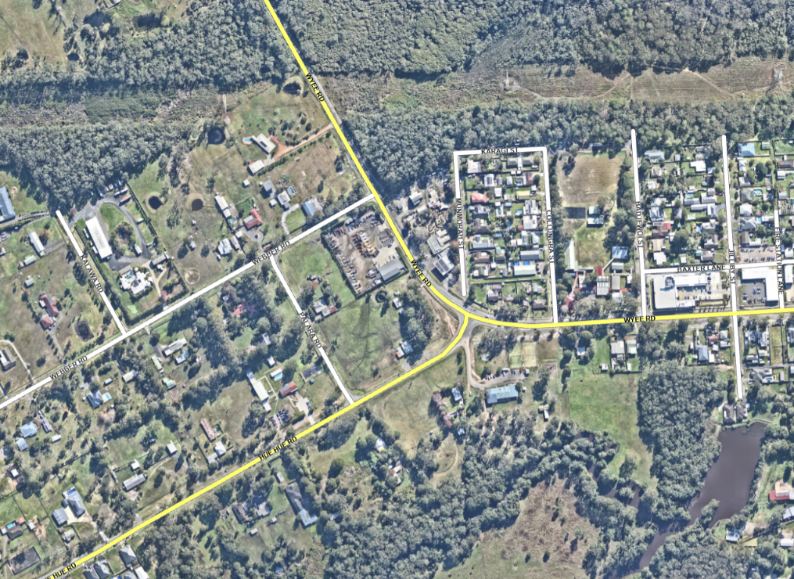
Subject
site
Wyee Public School
Wyee Park and community centre
Radcliffe Estate
Wyee Train Station
Current Local Centre
Morisset
Figure 1: Subject site and surrounding context
The site was included in Council’s Review and Strategy for RU4 Primary Production Small Lots zoned land which was endorsed by Council on 28 August 2023 (23SP062). The review and strategy assessed RU4 zoned land across the city to determine its potential for urban use. The review and strategy recommended that this site should be considered for urban development as part of future proponent-initiated planning proposals.

Discussion
The established Wyee local centre is located 300m to the east of the site. Wyee local centre has a range of shops and services including a small supermarket, pharmacy, bakery, medical centre and take away food restaurant. There is also some E1 Local Centre zoned land located on the opposite side of Wyee Road to the northeast, which contains a plant nursery and landscape supply business and a petrol station.
Recent and planned population growth in Wyee has increased, and will continue to increase, demand for local centre services and facilities. The current supply and use of E1 Local Centre zoned land in the area is insufficient to support the services and facilities required to meet this demand. The intended outcome of the planning proposal is to rezone the site from RU4 Primary Production Small Lots to E1 Local Centre so that extra local centre businesses, services and facilities can be provided to support population growth in the area.
The rezoning will enable a range of potential local centre developments such as shops, supermarket, food and drink premises, medical facilities, childcare and office premises. Given the current use and undersupply of E1 Local Centre zoned land in the region, the planning proposal should not affect the viability of ongoing commercial operations in existing employment zoned land. This includes the current local centre in Wyee, the plant nursery and petrol station on the opposite side of Wyee Road, and the larger nearby centre of Morisset.
The planning proposal also seeks increase building heights from 8.5m to 15m and change the minimum lot size from 1ha to no minimum lot size.
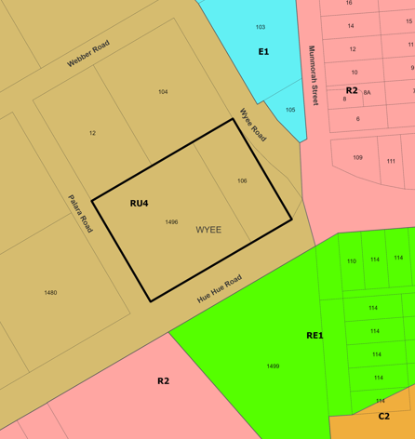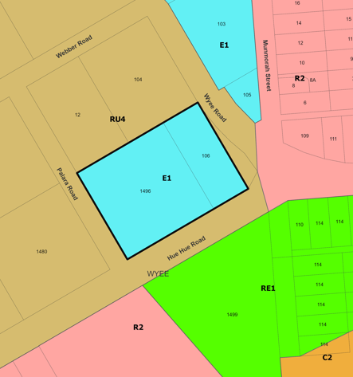
Figure 2: Current (left) and proposed (right) zones
The planning proposal will provide sustainable development, aligning with Council's Local Strategic Planning Statement (LSPS) which identifies Wyee as an urban intensification area. The LSPS seeks to concentrate growth in urban areas with access to existing infrastructure. The LSPS contains a specific goal for Wyee to establish its role as local centre with an increase in local centre businesses and services to cater for the growing population.
The site is considered suitable for the proposed zone which will support future development that is not anticipated to result in significant negative economic, environmental or social impacts.

Community engagement and internal consultation
Internal consultation has been undertaken with Environmental Systems, Development Assessment and Certification, Property and Business Development, Asset Management and Community Partnerships.
Public exhibition will occur in accordance with the Gateway Determination. The planning proposal is categorised as a standard planning proposal which has a recommended public exhibition period of 28 days.

Assessment of options
The planning proposal has site-specific and strategic merit as it proposes a suitably located local centre zone which will increase the availability of local centre facilities and services, support economic growth and diversification and provide direct and indirect employment opportunities to the growing local community.
It is recommended that Council supports the progression of the planning proposal. Progressing the planning proposal will enable an assessment by DPHI through a Gateway Determination and an opportunity for the community and other stakeholders to have a say through public exhibition.
Council may decide not to progress the planning proposal. This would impact the achievement of the LSPS goal for Wyee and mean that extra local centre businesses, services and facilities will not be provided to meet increasing demand. Development consistent with the current RU4 Primary Production Small Lot zone will continue to be permitted on the site if this option is pursued.

Next steps
If Council supports the recommendation, the planning proposal will be referred to DPHI for Gateway Determination. Subject to Gateway Determination, relevant state agencies and infrastructure providers will be consulted, and the planning proposal will be placed on public exhibition. Following public exhibition, Council will receive a further report detailing the submissions received and outcome of the state agency consultation and public exhibition.

Key considerations
Economic
The planning proposal will allow further development commensurate to the E1 Local Centre Zone in an area experiencing population growth. It will support potential future development providing economic opportunities and jobs in the area and improving access to local services and facilities. The proponent estimates that the site could result in development that would support up to 285 ongoing jobs.
Given recent and planned population growth and the current demand for local centre services and facilities, the planning proposal is considered to have minimal potential impact on the viability of businesses in nearby centres and E1 Local Centre zoned land.
Environment
The planning proposal has considered environmental matters applicable to the site and surrounding locality, including impacts on biodiversity, natural water systems and stormwater management, flooding, contamination, visual impact, heritage, bushfire, acid sulphate soils and geotechnical. It is considered that the site is appropriate to accommodate the proposed land use zone.
Community
The planning proposal will support potential future development of the Wyee local centre, which will deliver positive employment and business outcomes and increased community access to local centre services and facilities.
Civic leadership
The recommendation is consistent with the LSPS and Hunter Regional Plan 2041 and enables the planning proposal to progress to public exhibition. This will provide the community the opportunity to participate in the planning proposal process.
Financial
There are minimal financial implications for Council associated with the recommendation. The relevant fees outlined in Council’s fees and charges cover the staff time spent assessing the planning proposal and have been paid by the proponent.
Infrastructure
The planning proposal has considered the impact of potential future development on local infrastructure provision and servicing and finds that the site is suitably serviced, or can be suitably serviced, by existing public infrastructure. It is not expected that the proposed rezoning will place significant additional demand on public infrastructure, services or utilities.
Specific infrastructure requirements will be assessed in more detail during a future development application and relevant development contributions would also be considered at this stage.
Compliance
The planning proposal has been prepared in accordance with the Environmental Planning and Assessment Act 1979, the Environmental Planning and Assessment Regulation 2021, and Council’s procedure for Amending Local Environmental Plans.

Legislative and policy considerations
Environmental Planning and Assessment Act 1979
Environmental Planning and Assessment Regulation 2021
Lake Macquarie Local Environmental Plan 2014
Hunter Regional Plan 2041
Greater Newcastle Metropolitan Plan 2036
Lake Macquarie Local Strategic Planning Statement
Lake Macquarie Review and Strategy for RU4 Primary Production (Small Lots) Zoned Land
Lake Macquarie Housing Strategy 2021

Attachments
1. | Planning Proposal for Gateway Determination - 1496 Hue Hue Road and 106 Wyee Road, Wyee - RZ/4/2024 | Under separate cover | D11599830

